**Create the multiple container with single pod by using manifest(yaml) file in Kubernetes:**

* First create the ec2 instance(t2.medium)
* update the server.
* Install the docker and minikube
* install kubectl on ec2 instance by using commands.
* Give the execute permissions to minikube
* Give the execute permissions to kubectl files.
* Move the minikube and kubectl are in the same path or same folder.
* By using command: **vi anil.yml**

Yaml file to create the two containers with single pod

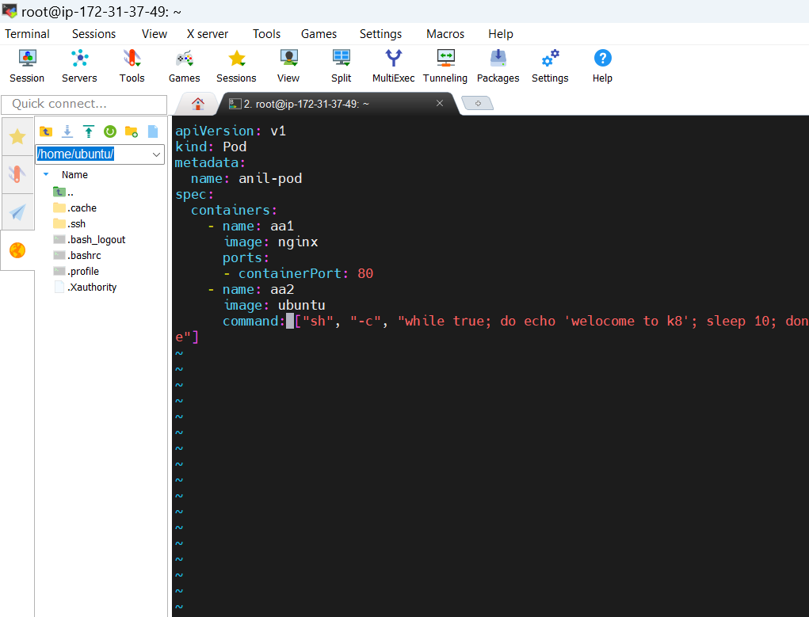

Pod creation and running status

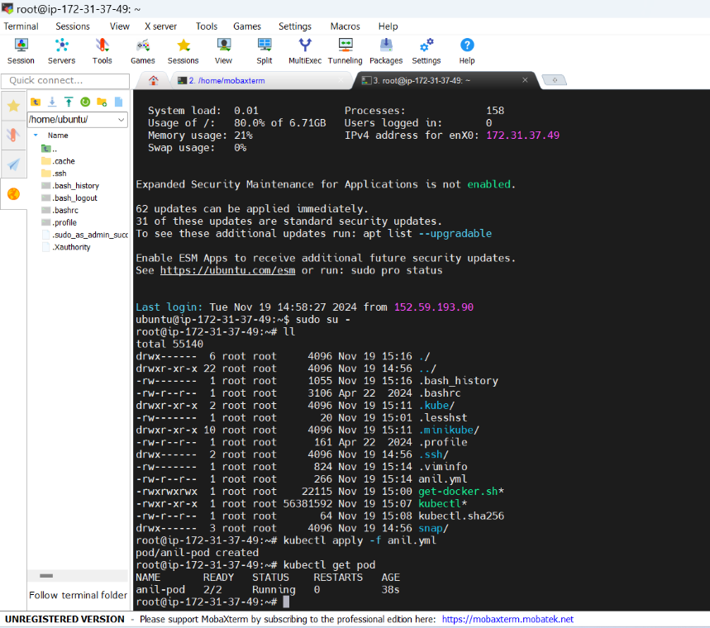

* To describe pod by using
* **kubectl describe pod podname** command
* It will show the information about the pod like running status ,containers running status and i.p address of node.

Container112 is in running status

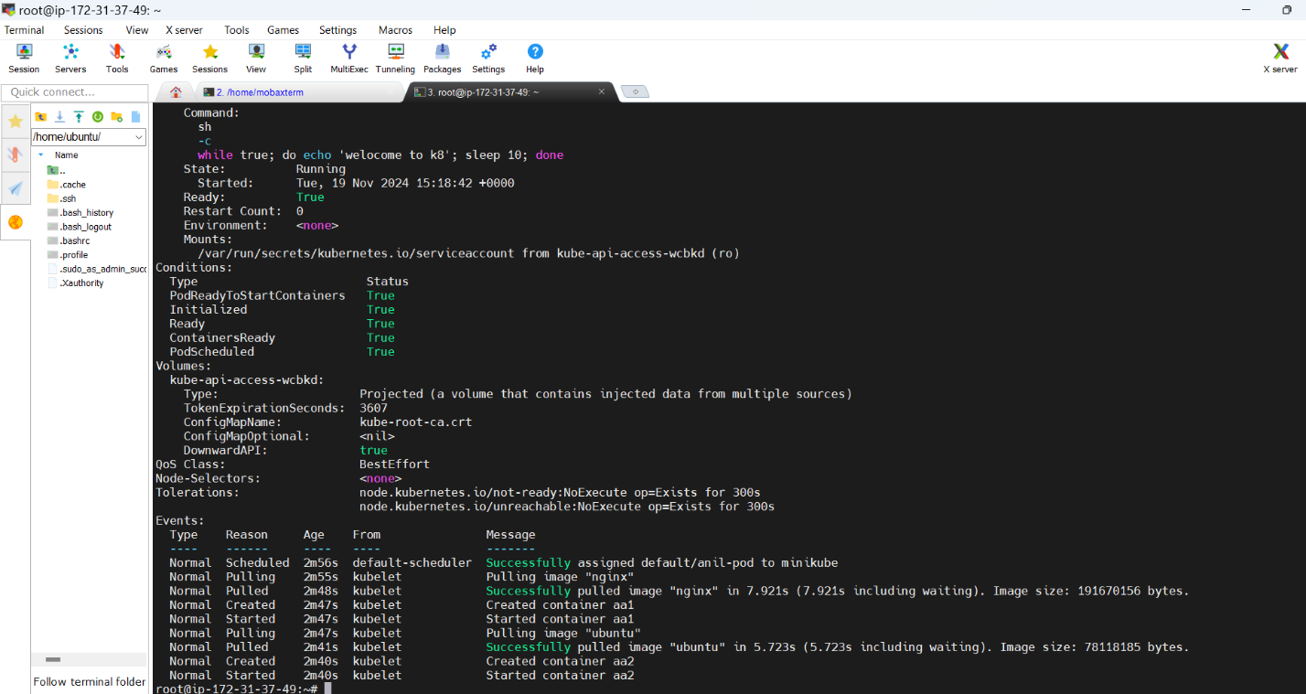

Container199 is in running status

